If you are interested in participating in the Little Bushey Patient Participation Group, please sign up by completing this form and returning it to Reception:

I wish to join the Little Bushey Surgery Patient Participation Group (LBSPPG)
Title | Mr □ | Mrs □ | Miss □ | Ms □
First Name
Last Name
Preferred Contact Number
E-mail address
Postcode
Your gender | Male □ Female □
Age group | Under 16 □ 17-24 □ 25-34 □ 35-44 □ 45-54 □ 55-64 □ Over 65 □
Ethnicity | British Group □ White & Black African □ Indian □ Chinese □ White & Black Caribbean □ Irish □ Bangladeshi □ Pakistani □ White & Black Asian □

We will contact you with details of our next meeting.

Alternatively you can visit our website at www.littlebusheysurgery.nhs.uk

LITTLE BUSHEY SURGERY
Patient Participation

California Lane

Bushey

WD23 1EZ

Tel: 020 8386 8888

www.littlebusheysurgery.nhs.uk

December 2007

WHAT IS THE ROLE OF THE PATIENT PARTICIPATION GROUP?
The patient participation group refers to patients who wish to take a more active interest in their local practice and in developing local healthcare services.
The idea is that patients and staff work together to share ideas to help improve the services offered at the Practice, as well as to help patients to take more responsibility for their own health. It also gives patients a say in how services are planned and evaluated, by developing a good working relationship with the practice staff and GPs. PPG’s are representatives of the practice population and therefore act as a channel of communication between the practice and its patients.
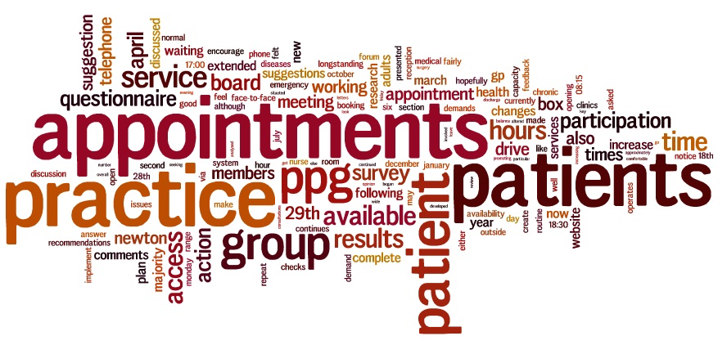MORE ABOUT WHAT A PATIENT PARTICIPATION GROUP CAN DO
- Carry out surveys to understand the views of the wider patient population
- Work with the practice to promote health education initiatives
- Run services to meet local needs such as befriending or carer support
- Let the practice staff know more about the level and standard of service
provided from a patient perspective
- Help the practice decide on overall service priorities
- Communicate to patients any changes to the NHS that will affect
services provided
- Provide information on help available, support groups and networks
- Help improve the experience of attending the Surgery
- Support the practice in the delivery of care

WHO WILL BE IN THE PATIENT PARTICIPATION GROUP?

Initially there will be a GP, Practice Manager, Nurse and Patients drawn from across the surgery, representative of the Practice population. This is flexible and can be adapted as the group gets more established.

WHAT THE PATIENT PARTICIPATION GROUP IS NOT ABOUT.

The group will not deal with personal medical issues or individual patient complaints, as we already have a well established procedure to deal with these.

HOW WILL I GET FEEDBACK FROM THE PATIENT PARTICIPATION GROUP?

- Regular meetings
- Practice Newsletter
- Information will be available in the waiting room at the surgery
- Information will be available on the practice website

SO NOW IT’S OVER TO YOU!

The patient participation group will only work well if patients communicate with us. We already have many ideas but would really appreciate your input and look forward working with you to enable us to provide the best possible service for our patients.

