We have been receiving many queries about the Covid-19 vaccine and allergies.
May we ask you to refer to the following links, which may give you a swift answer to your question, and if you are still unsure after, to kindly call reception, as we want to try to make sure those with medical needs can still access appointements.
Common questions:
- What is a Anaphylactic reaction?
https://www.anaphylaxis.org.uk/what-is-anaphylaxis/patient-signs-and-symptoms/
Please refer to the ABC symptoms, for further information.
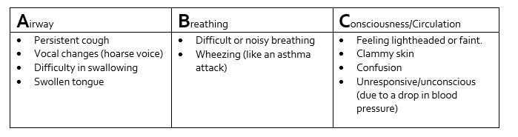
If you have not had these symptoms before to a drug, medication, or other substance, then it would be assumed for you to be safe to have the vaccine.
- If I have had an allergy previous to Penicillin, other antibiotics, or food – can I have the vaccine?
If the allergy did not cause ABC symptoms, as above, then, yes, you can still have the vaccine.
If you have had a mild to moderate reaction to a medication or food, then there is no need to avoid the vaccine.
At the vaccine venue, they have access to medication if needed if someone had an allergic reaction, and they will observe you for a 15 minute period after the vaccine as well.
The latest information in the Green Book states:-
‘Following close surveillance of the initial roll-out, the MHRA has advised that individuals with a history of anaphylaxis to food, an identified drug or vaccine, or an insect sting CAN receive any COVID-19 vaccine, as long as they are not known to be allergic to any component (excipient) of the vaccine. All recipients of the Pfizer BioNTech COVID-19 vaccine should kept for observation and monitored for a minimum of 15 minutes. Facilities for management of anaphylaxis should be available at all vaccination sites.’
At the venue, they will ask about your allergies again, and they will be able to discuss with you further if there are concerns on your end.
There is also more information available at - https://www.anaphylaxis.org.uk/covid-19-advice/pfizer-covid-19-vaccine-and-allergies/
If there are follow up questions after this, kindly speak to reception, and one of our colleagues should be able to help.

Many thanks for your co-operation,
Little Bushey Surgery

