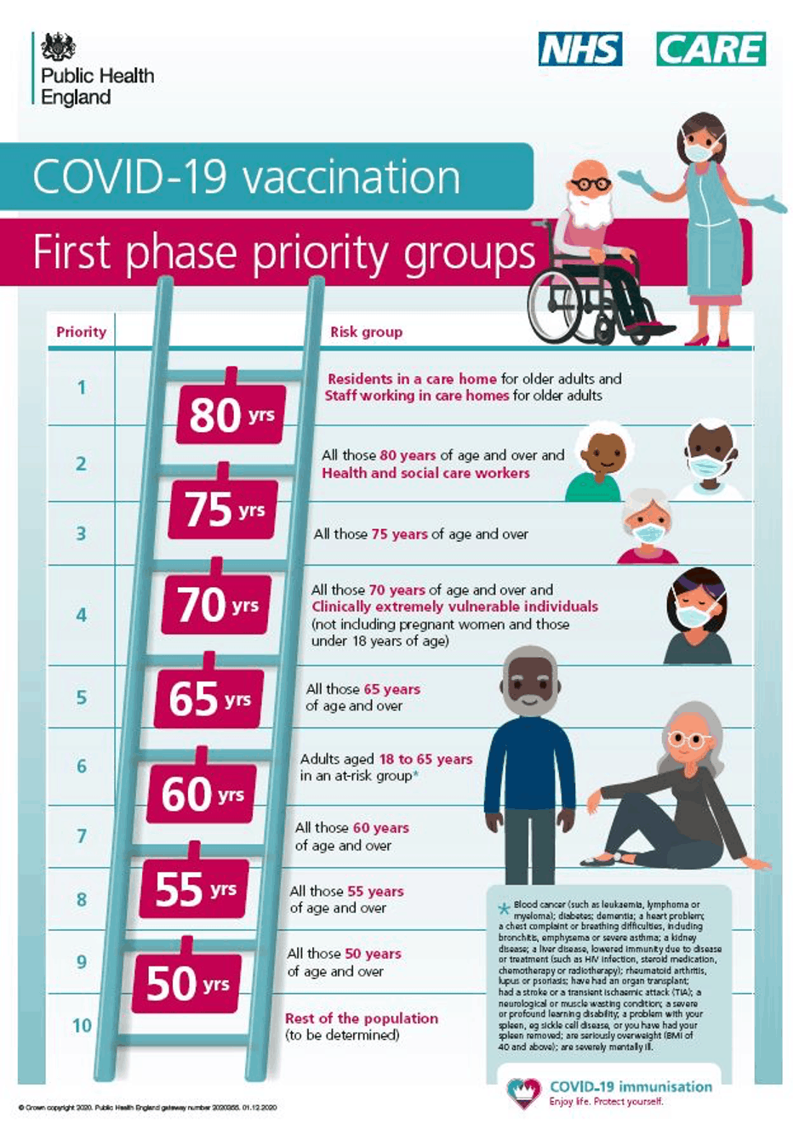

Frequently Asked Questions about the COVID vaccination programme in Hertsmere
1. Q. How do I get my vaccine?
A. There are 2 different ways to get your vaccine.
1. The surgery will contact you to book an appointment at the new vaccination hub in Allum Lane, Borehamwood.
OR
2. If you have received a letter from the NHS inviting you to book an appointment at a vaccination centre (our nearest one is in Stevenage), then you can follow the instructions in the letter to book your appointment on the Book a coronavirus vaccination - NHS
Even if you receive a letter from the NHS you will still be invited to Allum Hall by us, so do not worry, and please don’t contact the surgery.
You cannot book online for the centre at Allum Hall.
Please DO NOT go to Allum Hall without being invited by the surgery.
2. Q. When will I get my vaccine?
A. You will be contacted when your vaccination is available. This will happen in order of priority set out by national guidelines.
More information about how the vaccine will be rolled out to groups of people in order of priority, starting with those who most need protecting from the virus, is on the Why you have to wait for your COVID-19 vaccine - GOV.UK webpage or see a copy of Why do I have to Wait? Leaflet.
3. Q. Where will I get my vaccine?
If you are contacted by the surgery, you will be able to have your vaccination at Allum Hall, Allum Lane, Borehamwood.
If you receive a letter from the NHS, and you wish to book your own appointment at another test centre, please follow the instructions in your letter.
Please note, there will be capacity for all Little Bushey Surgery patients at the centre in Allum Hall, so this is completely your choice, but please do not contact Allum Hall if you are trying to book an appointment yourself.
4. Q. I am housebound, and I am unable to leave my house. How will I get my vaccine?
A. CLCH, the provider of our local district nurse service will arrange for you to have the vaccine. This is not arranged by Little Bushey Surgery and we do not have dates for when this will happen. If you are invited to come to Allum Hall, it is highly likely you would receive the vaccination sooner by coming to the centre, so if you can make the short journey, then please do. The housebound service is for those patients who cannot leave their homes, not for those who are choosing to remain in their homes.
5. Q. What happens at the vaccination centre?
A. Please follow the following guidance:
- Please arrive at the time of your appointment.
- Wear clothes so that the very top of your arm is easily accessible (there won’t be anywhere for you to fully undress!)
- You must wear a face mask.
- Please bring a current prescription list if available. Bring your yellow book if you take warfarin.
- Wherever possible, please come unattended. Wheelchairs are available if needed. In case of need, please speak to one of our stewards who will help you.
We will do some brief identification and health checks
You will promptly have your injection and then be asked to sit and wait for 15 minutes after the vaccination. Once the 15 minutes have passed, you will then be able to leave and go home.
6. Q. Which vaccine will I receive, and can I request a specific vaccine?
A. Eventually all three approved vaccinations, Pfizer/BioNTech, Oxford AstraZeneca and Moderna will be available. You will receive whichever vaccine is in use on the day of your appointment. It will not be possible to request a specific vaccine
7. Q. I am a carer. When will I receive the vaccine?
A. Carers are in Group 6 of the priority list. This is the same group as those under 65 with long term conditions. Therefore this only applies to carers under the age of 65. If you are a carer, please register on our website so that we know to contact you. Unfortunately, we can only invite carers in group 6 if you are registered with us as a carer.
8. Q. My partner/spouse is over 80 but I am under 80, surely I need the vaccination at the same time as my partner?
A. If your spouse/partner is in the immediate next priority group eg you are 82 but spouse is 79, please inform the booking staff when you are called. They may be able to assist booking both appointments for you.
Unfortunately, if you are in a different priority groups we cannot guarantee that you will both receive vaccines at the same time.
Please do not contact the surgery asking for an exception to this as it puts unnecessary pressure on our staff who have to refuse your request.
9. Q. I am clinically extremely vulnerable (shielding). Shouldn’t I and my family receive the vaccine sooner?
A. If you are in the shielding group (clinically extremely vulnerable) then you are in group 4 in the priority list. This is the same group as those over 70 years old. You will be called when we reach this group.
Family members of those who are shielding will be called for vaccination only when their own priority group is called.
10. Q. I am a healthcare professional, how will I get the vaccine?
A. Please contact us and let us know you are a healthcare professional You will need to tell us your profession, employer and professional registration (if applicable) eg GMC/NMC number
11. Q. I have allergies, can I still have the vaccine?
A. If you have had a serious (anaphylactic) reaction to any component of the vaccine, then you shouldn’t have the vaccine. The list of components can be found here:
- Pfizer
- Astra Zeneca
Individuals with a history of anaphylaxis to multiple drugs or to unknown causes, should be offered the AstraZeneca vaccine
Individuals with a history of anaphylaxis to food, an identified drug or vaccine, or an insect sting can receive any COVID-19 vaccine, as long as they are not known to be allergic to any component of the vaccine
12. Q. I take blood thinners. Can I receive the vaccine?
A. Yes, but please advise the person giving you the vaccine before they give you the injection.
13. Q. I am pregnant or breastfeeding. Can I receive the vaccine?
A. If you are breastfeeding, you can receive the vaccine
If you are pregnant, think you might be pregnant, or trying to conceive, you should not normally receive the vaccine.
The only exception to this is if you also have an underlying health condition that puts you at high risk of complications of coronavirus infection, or if you work somewhere where you at high risk of getting coronavirus such as a hospital or care home facility. Please discuss with a GP or your employer if this is the case.
14. Q. I have recently had coronavirus, or think I might have developed coronavirus before my vaccination. What should I do?
A. Please do not attend for your vaccination if you have any symptoms that might be due to coronavirus:
- Fever
- Cough
- Loss or change of sense of smell
Attending a vaccination centre with those symptoms is putting other people at risk.
You should not have the vaccine within 4 weeks of any coronavirus symptoms, within 4 weeks of testing positive for coronavirus even if you had no symptoms or if you are awaiting the result of a coronavirus test.
15. Q. Once I have received my vaccine, can I socialise with others who have also been vaccinated?
A. This is a really important question. Vaccination protects the community. It may not protect every single individual. A small number of people will not be protected by the vaccine, and we don’t know who this will be. We also don’t yet know if the vaccine stops you passing on coronavirus. It is of the utmost importance that even after you and your loved ones have received the vaccine, that you continue to follow the guidance for social distancing and any other restrictions that are in place. Once the community infection rates fall, then restrictions will start to be lifted.
16. Q. My specific question has not been answered
A. Please visit Herts Valleys CCG for further information

