Over five thousand Hertfordshire families are missing out on £100’s of food and milk vouchers
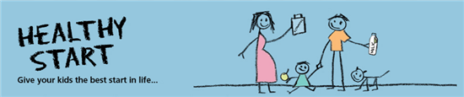
Are you pregnant or have a child under four? Did you know you could be missing out on free fruit and vegetables or milk?
If you are at least 10 weeks pregnant or have a child under four years old you could be entitled to Healthy Start Vouchers worth £3.10 per child per week, to spend on milk, plain fresh and frozen fruit and vegetables, and instant formula milk. You can also use them to buy pulses and canned fruit and vegetable as long as they have no fat, salt, sugar or other flavouring added. The vouchers can be redeemed at local retailers.
If you are entitled to Healthy Start Vouchers you will also get free vitamins designed to help pregnant and breastfeeding women and growing children.
Pregnant women and every child over one and under four years old can get one voucher every week. Children under one year old can get £6.20 per week.
To be eligible you should be in receipt of certain means-tested benefits. Check your eligibility on www.gov.uk/healthy-start
For example, a parent with a new baby and a 3 year old could get vouchers worth almost £500 a year.
You can still receive the vouchers if you live with your partner and they receive one of these benefits or you are the dependent child of someone who receives them. If you are pregnant and under 18 you do not have to be in receipt of any benefits to qualify.
Take-up of the vouchers is very low, around 40 percent, so check you are entitled as soon as possible to prevent missing out.
You can phone for a form on 0345 607 6823 or download and print one from www.healthystart.nhs.uk/healthy-start-vouchers/how-to-apply/.
Due to COVID19 restrictions the form does not need to be signed by a health professional
You can also use the benefit-checker on the County Council’s website, and access free information about benefits that you might be missing-out on – www.hertfordshire.gov.uk/benefits

