**Step 1:**

Once you have collected your **online registration letter** from reception, log onto patient access **https://patient.emisaccess.co.uk/account/login**

This should be the first screen you see

Click on the GREEN button to REGISTER

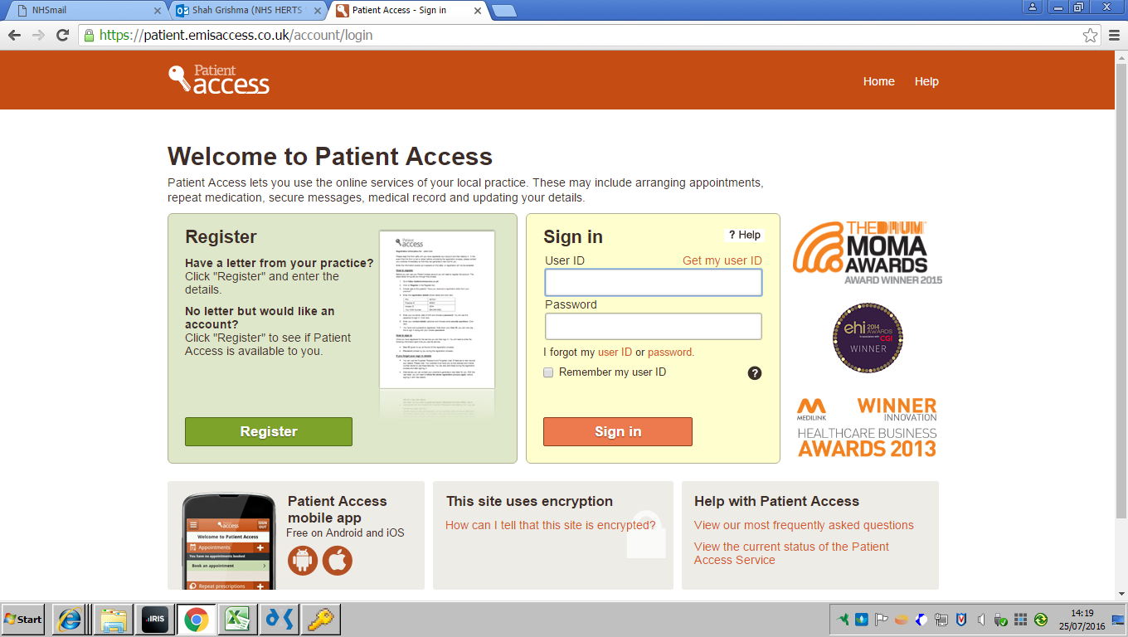

**Step 2:**

Click on YES if you have the letter from our practice

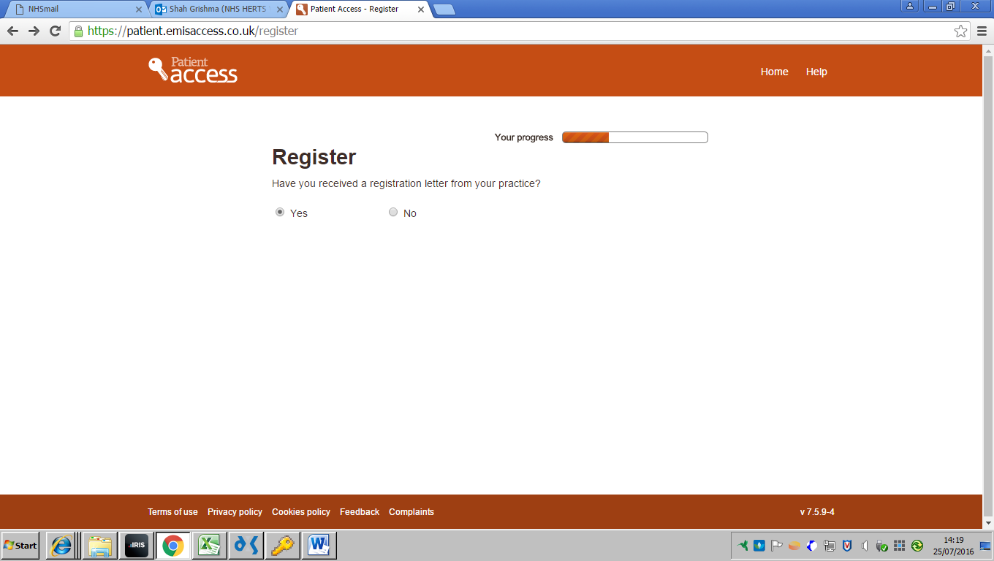

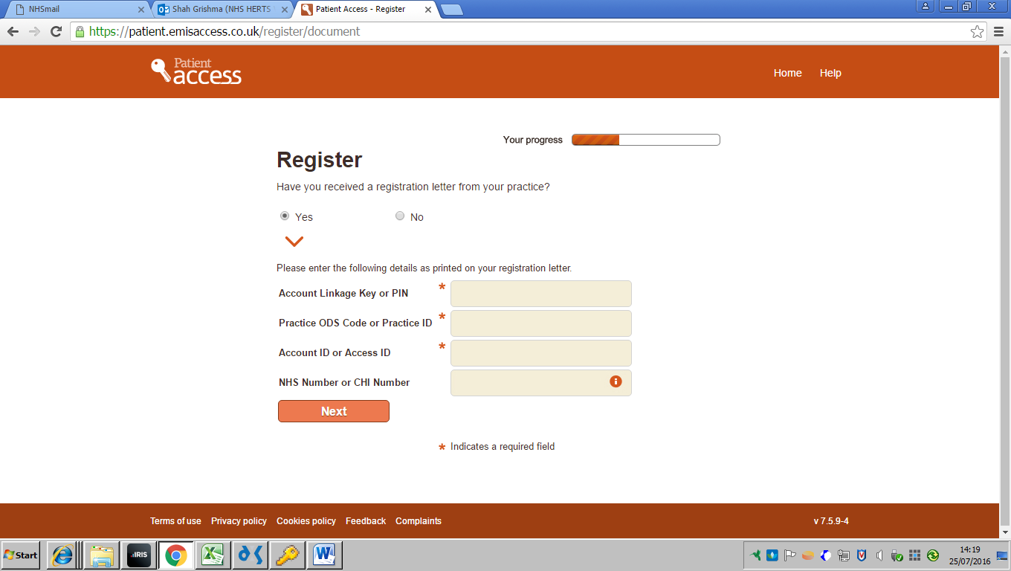

**Step 4:**

Fill in your details

And create a password

**Step 3:**

Fill in the details which can be found on your letter

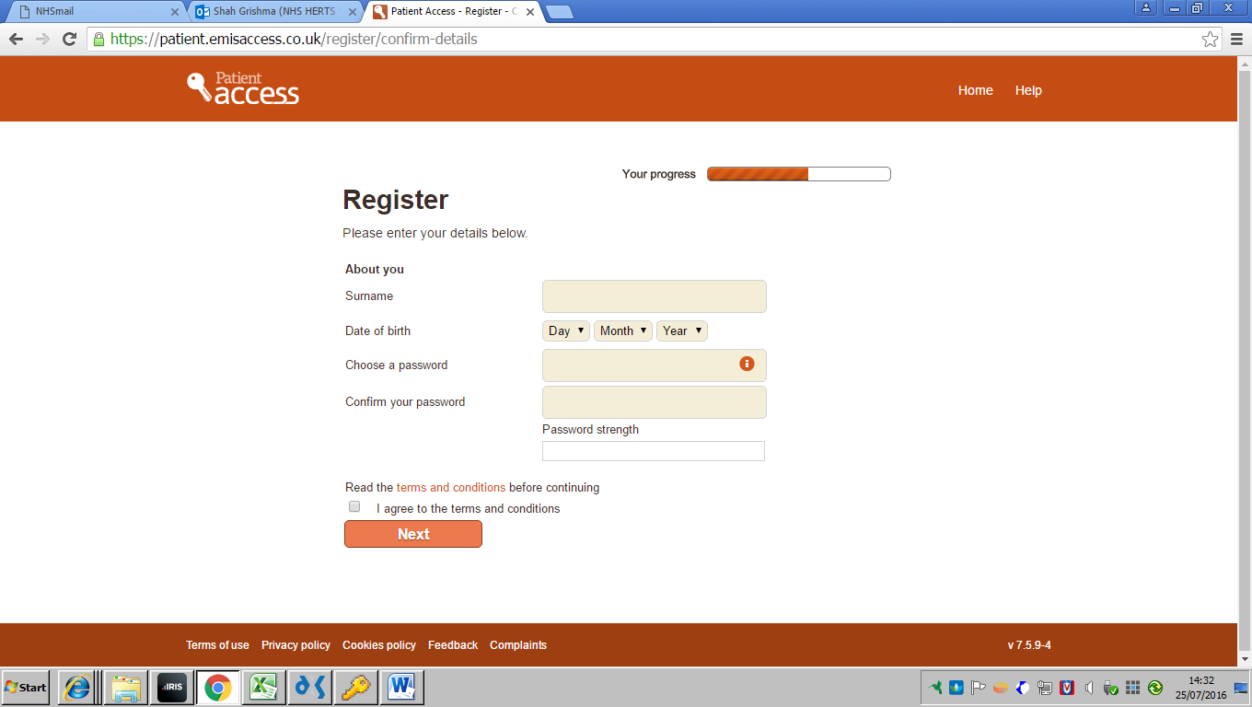

**Step 5:**

Make sure you agree to the terms and conditions by ticking the box

v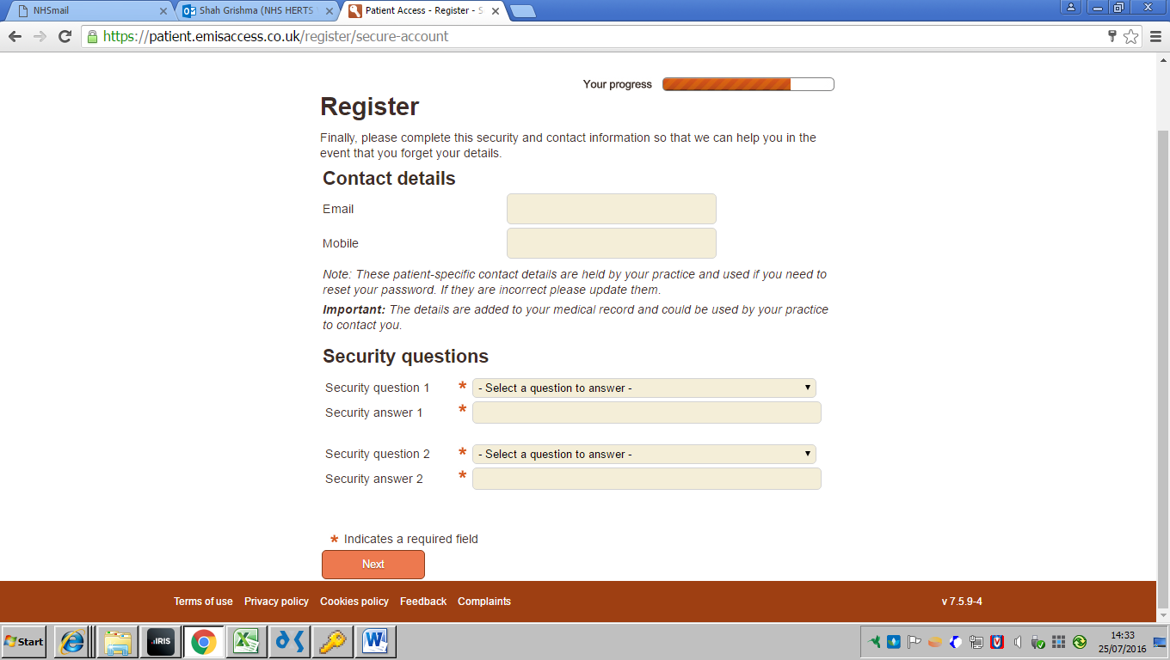

**Step 7:**

Answer the 2 security questions

**Step 6:**

Enter your email address and if you have a mobile number enter that below

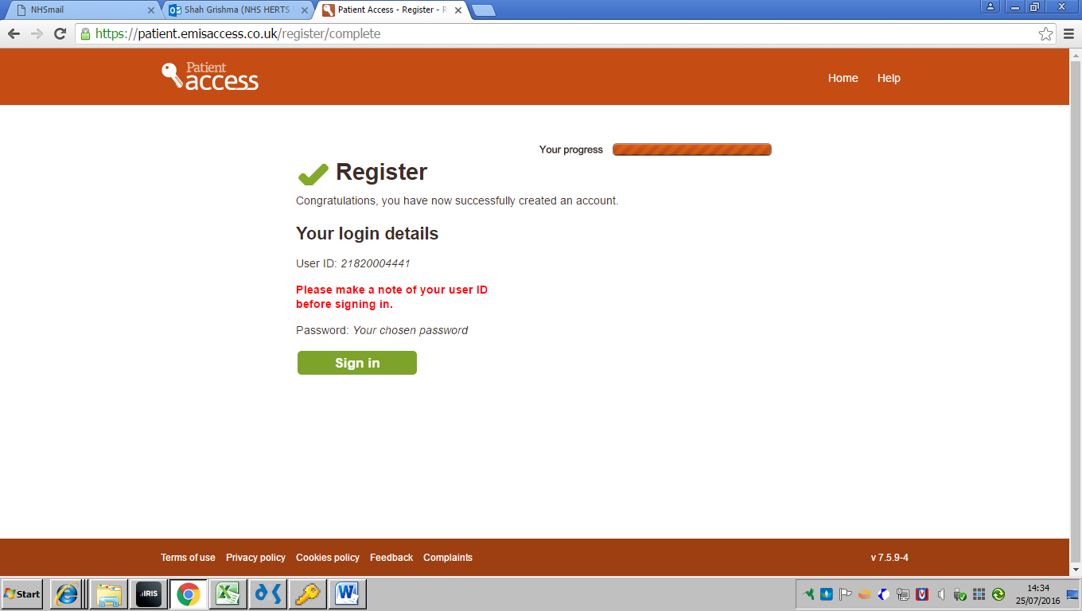

**Step 8:**

If you have completed steps 1-7 correctly, then you should see this as your final page.

Please make a note of your ID number